HAZARDOUS MATERIALS BUSINESS PLAN

II. Chemical Inventory and Site Map (continued)

SITE MAP INSTRUCTIONS

Use the instructions below to develop and submit your site map to the CUPA through CERS as part of the HMBP. The site map is to assist response personnel in locating hazardous materials and responding to emergencies at your facility. Please upload site maps in PDF format, and use the Standardized Site Map Symbols and the Standardized Hazard Category Symbols only.

PLEASE NOTE: not all symbols are mandatory, however use of standard symbols (pages 9 -11) on your site map assists fire and other first responder services in an emergency at your facility. Do not use a legend with standard symbols.

SITE MAP LAYOUT

Use the following information to construct your site map:

- Site Map must be on 8-1/2 x 11 inch size paper ONLY, but does not need to be drawn to scale. For larger facilities, consider using multiple pages; one for the overall layout of the facility and additional pages for individual buildings. Rural areas should include an inset vicinity map of the greater area. Site maps with multiple pages must be uploaded to CERS as a single file.

- Maps should be black & white line drawings. Do not use color coding.

- All labels, symbols, writing, printing shown on the site map must be legible and oriented in the same direction. Maps may be drawn on a computer or by hand using a ruler or template to draw the lines and symbols.

- Do not use large documents (such as blue prints) unless the scaled-down result is clearly legible. Engineering markings and other non-essential items should be removed for clarity.

- Show structures from an overhead perspective. Show only the exterior walls of small buildings and include all exits and entrances. Interior walls may be shown for complex or large facilities.

- Include roads that provide access and exit points to the facility, including driveway entrances, internal roads, parking lots, loading areas and adjacent streets.

- Indicate all hazardous materials/waste handling and storage areas using appropriate symbols.

- Indicate all emergency and main utility shutoffs using appropriate symbols. If you do not have a utility service (such as gas), it is helpful to indicate this inside a cloud (e.g. “no gas”) on the map.

- Indicate evacuation staging area using appropriate symbols.

- Indicate storm and sewer drains using appropriate symbols.

- Indicate fire hydrants and other fire department connections using appropriate symbols.

- Indicate other emergency response equipment (fire extinguisher, eye wash, spill kit) using appropriate symbols or by labeling the location of emergency equipment on the site map.

- In the upper left corner, indicate the North orientation by drawing an arrow pointing north.

- Label adjacent property usages (school, park, industrial, residential, commercial, vacant, etc.).

SITE MAP STANDARD SYMBOLS

Entrances/Exits: Use this symbol for all exterior doors of structures, including roll-up doors.

Fences: Use this symbol for fences (e.g. chain link, wood, etc.), block walls, or any other barriers that act as a fence. (Note: include both external and internal fences). |  | x x x x
Sewer Drain: Use this symbol to show all sewer drains, including floor drains to sewer, sewer sumps, etc. (Note: do not include toilets and sinks). |  | S
Storm Drain or Culvert: Use this symbol to indicate the location of all storm drain inlets, culverts, drainage ditches and other rain water diversion features on the property. If none are present in the scope of your map, indicate the distance to the nearest storm drain using an arrow to indicate the direction and this symbol. |  | 
Electric MAIN Shut Off: Use this symbol to indicate only the electric main shut-off or the entire facility, structure, or building. |  | E
Water MAIN Shut Off: Use this symbol to indicate only the water main shut-off for the entire facility, structure, or building. |  | W
Gas MAIN Shut Off: Use this symbol to indicate only the natural gas main shut-off for the entire facility, structure, or building. You may indicate “no gas” in a cloud if there is no gas service. |  | G  +
Emergency Response Equipment: Use this symbol to indicate the location of emergency response equipment such as spill kits, fire extinguishers, and eye wash stations. A text label may be used to differentiate emergency response equipment types.

Fire Hydrants: Use this symbol to identify all fire hydrants in the vicinity of your facility. If none are present in the scope of your map, indicate the distance to the nearest fire hydrant using an arrow to indicate the direction and this symbol.

Fire Sprinkler System Connection: Use this symbol to identify the building/structure fire department sprinkler system connections if present at your facility. (Note: these are normally located outside in locations accessible to the fire department. Do not include landscape sprinkler connections).

Fire Department Standpipe Outlet: Use this symbol to identify the fire department standpipe fire hose connections if present at your facility. (Note: these connections are typically found inside buildings and in stairwells of multi-story buildings.)

Knox Box (Fire Department Key Box): Use this symbol to indicate the location of the Knox Box (a locked box containing keys or information for the Fire Department.) if present at your facility. |  | K
Annunciator Panel: Use this symbol to indicate the location of the Annunciator Panel if present within the facility. An annunciator panel indicates the zone or area from which an alarm has been initiated; or the location of an alarm-initiating device and the operational condition of the alarm circuits of the system. |  | AP
Stairwell - Range of Floors (e.g., B thru 5): Use this symbol to indicate interior stairwells, if present. Indicate the floor the stairwells begin and end on. For roof access use the abbreviation R. For basement access use the abbreviation B and include the number of basement floors

Elevator - Range of Floors (e.g., B thru R): Use this symbol to indicate the elevators in the interior of a structure or building, if present. Indicate the floor the elevator begins and ends on. For roof access use the abbreviation R and include the beginning floor level. For basement access use the abbreviation B and include the number of basement floors. |  | 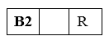
Safe Refuge Area (Evacuation/Staging Area): Use this symbol to indicate the location that has been designated as the assembly area where plant or business personnel will assemble in the event of an emergency evacuation.

Aboveground Storage Tank and Capacity: Use the correct circle or oval symbol for aboveground storage tanks onsite, if present. Include the tank capacity within the symbol using the appropriate unit of measure as reported in CERS. Also include the appropriate hazard category symbols (diamonds or circles) for the tank contents. See below. |  | 500  90
Plating or Processing Tanks: Use this symbol for all plating and process tanks if present at your facility. Also include the appropriate hazard category symbols (diamonds or circles) for the tank contents. See below. |  | 5, 000
Underground Storage Tank and Capacity: Use this symbol for underground storage tanks onsite, if present. Include the tank capacity within the symbol with the appropriate unit of measure as reported in CERS. Also include the appropriate hazard category symbols (diamonds or circles) for the tank contents. See below. |  | 500
HAZARD CATEGORY SYMBOLS: Use the symbols below to identify the location and hazards associated with hazardous materials stored in reportable quantities and all hazardous wastes handled at your facility. Use your Safety Data Sheet or other technical resources (such as 49 CFR 171.101) to determine the appropriate hazard class(es) for each. | USE  DIAMONDS  FOR  MATERIALS | USE  CIRCLES  FOR  WASTES
IMMEDIATE (ACUTE) HEALTH HAZARD: An adverse effect resulting from a short-term exposure to a chemical. Includes highly toxic, toxic, irritant, sensitizers, corrosive chemicals. Examples: cyanide, hydrochloric acid, sodium hydroxide, and chlorine. | IA  IA | IA
DELAYED (CHRONIC) HEALTH HAZARD: An adverse effect resulting from long-term exposure to a substance. The effects could be a skin rash, bronchitis, cancer or any other medical condition. Examples include carcinogens such as benzene, formaldehyde, or methylene chloride. | DC | DC
FIRE HAZARD: Includes flammable liquids and solids, combustible liquids, pyrophorics and oxidizers. Examples include solvents like acetone and alcohol, solvent based paints, gasoline, naphtha solvent, acetylene gas cylinders, propane gas. | FH  FH  FH | FH
SUDDEN RELEASE OF PRESSURE: This category includes explosives, blasting agents and compressed gases. Examples: nitrogen, oxygen, acetylene, helium, carbon dioxide, etc. | SR  SR | SR
REACTIVE: This category includes unstable air reactive, water reactive or shock materials. Examples: organic peroxides, fine metal dusts like magnesium, aluminum, phosphorous, cyanides, sulfides and picric acid | R  R  R | R
MEDICAL (BIOHAZARDOUS) WASTE: Medical or biohazardous wastes generated in medical, dental and lab settings. Typically needles and syringes in sharps containers, infectious materials in biohazard bags, clinical and microbiological lab specimens and some pharmaceutical waste. | Use the appropriate symbol from this column | IW
RADIOACTIVES: Includes mixed waste and radioactive sources used in labs and industrial settings. Examples include: Scintillation materials, nuclear medicine waste and R & D materials and waste. | RA  RA | RA
EXTREMELY HAZARDOUS: Includes materials listed in Appendix A of Part 355 of Subchapter J of Chapter 1 of Title 40 of the Code of Federal Regulations. Examples include fluorine gases, silane, and fumigation gases. | XH | XH

HMBP STANDARDIZED SITE MAP SYMBOLS
SITE MAP SYMBOLS |  |  |  |  |  |  |  |  |  |  |  |  |  |  | HAZARDOUS MATERIALS STORAGE/USE AREA SYMBOLS
ENTRANCE/EXIT |  |  | FENCE  x x x x |  |  |  |  | SAFE REFUGE AREA |  |  |  |  |  | IMMEDIATE (ACUTE) HEALTH HAZARD  An adverse effect resulting from a short-term exposure to a chemical. Includes highly toxic, toxic, irritant, sensitizers, corrosive chemicals. Examples: cyanide, hydrochloric acid, sodium hydroxide, chlorine gas |  |  | MATERIAL  IA |  | WASTE  IA
EMERGENCYRESPONSE EQUIPMENT  + | SEWER  DRAIN  S |  |  |  |  | FIRE  HYDRANT |  |  |  |  |  | STORM DRAIN  OR CULVERT |  | DELAYED (CHRONIC) HEALTH  An adverse health effect resulting from long-term exposure to a substance. The effects could be a skin rash, bronchitis, cancer or any other medical condition. Examples include carcinogens such as benzene, formaldehyde, and methylene chloride.  DC |  |  |  | DC
FIRE SPRINKLER CONNECTION |  | F.D. STANDPIPE OUTLET |  |  |  |  |  | KNOX BOX |  |  |  |  |  | FIRE HAZARD  Includes flammable liquids and solids, combustible liquids, pyrophorics and oxidizers. Examples include solvents like acetone and alcohol, solvent based paints, gasoline, naphtha solvent, acetylene gas cylinders, propane gas. |  |  | FH |  | FH
 |  |  |  |  |  |  |  | K
 |  |  |  |  |  |  |  |  |  |  |  |  |  | SUDDEN RELEASE OF PRESSURE  This category includes explosives, blasting agents and compressed gases. Examples: nitrogen, oxygen, acetylene, helium, carbon dioxide, etc.  REACTIVE  This category includes unstable air reactive, water reactive or shock materials. Examples: organic peroxides, fine metal dusts like magnesium, aluminum, phosphorous, cyanides, sulfides and picric acid. |  |  | SR |  |  | SR
STORAGE TANKS AND CAPACITY
UNDERGROUND |  |  |  | ABOVE GROUND PLATING TANKS |  |  |  |  |  |  |  |  |  |  |  |  | R
500 |  |  |  | 500 |  |  | 50  OR |  |  |  | 5, 000
MAIN UTILITY SHUT OFFS |  |  |  |  |  |  |  |  |  |  |  |  |  |  |  |  |  |  | R
ELECTRICAL |  |  |  | GAS |  |  |  |  |  | WATER |  |  |  | MEDICAL (BIOHAZARDOUS) WASTE  Medical or biohazardous wastes generated in medical, dental and lab settings. Typically needles and syringes in sharps containers, infectious materials in biohazard bags, clinical and microbiological lab specimens and some pharmaceutical waste.  RADIOACTIVES  Includes mixed waste and radioactive sources used in labs and industrial settings. Examples include: Scintillation materials, nuclear medicine waste and R & D materials and waste.  EXTREMELY HAZARDOUS  Includes materials listed in Appendix A of Part 355 of Subchapter J of Chapter 1 of Title 40 of the Code of Federal Regulations.  Examples include: Fluorine gases, Silane, Fumigation gases |  |  | Use the appropriate symbol from this column  RA |  | RA  IW
E |  |  |  | G |  |  |  |  |  | W
 |  |  |  |  |  |  |  |  |  |  |  |  |  |  |  |  | XH |  | XH
ANNUNCIATOR PANEL  AP |  |  |  |  | STAIRWELL  (i.e. 1 thru 3) |  |  |  |  | ELEVATOR  Range of Floors

SAMPLE SITE MAP (Page 1 of 1)

BUSINESS NAME Joe’s Automotive Repair _________________________________ DATE 02/09/2016

BUSINESS ADDRESS 1234 Somewhere Pl., Anywhere, CA 92123
N

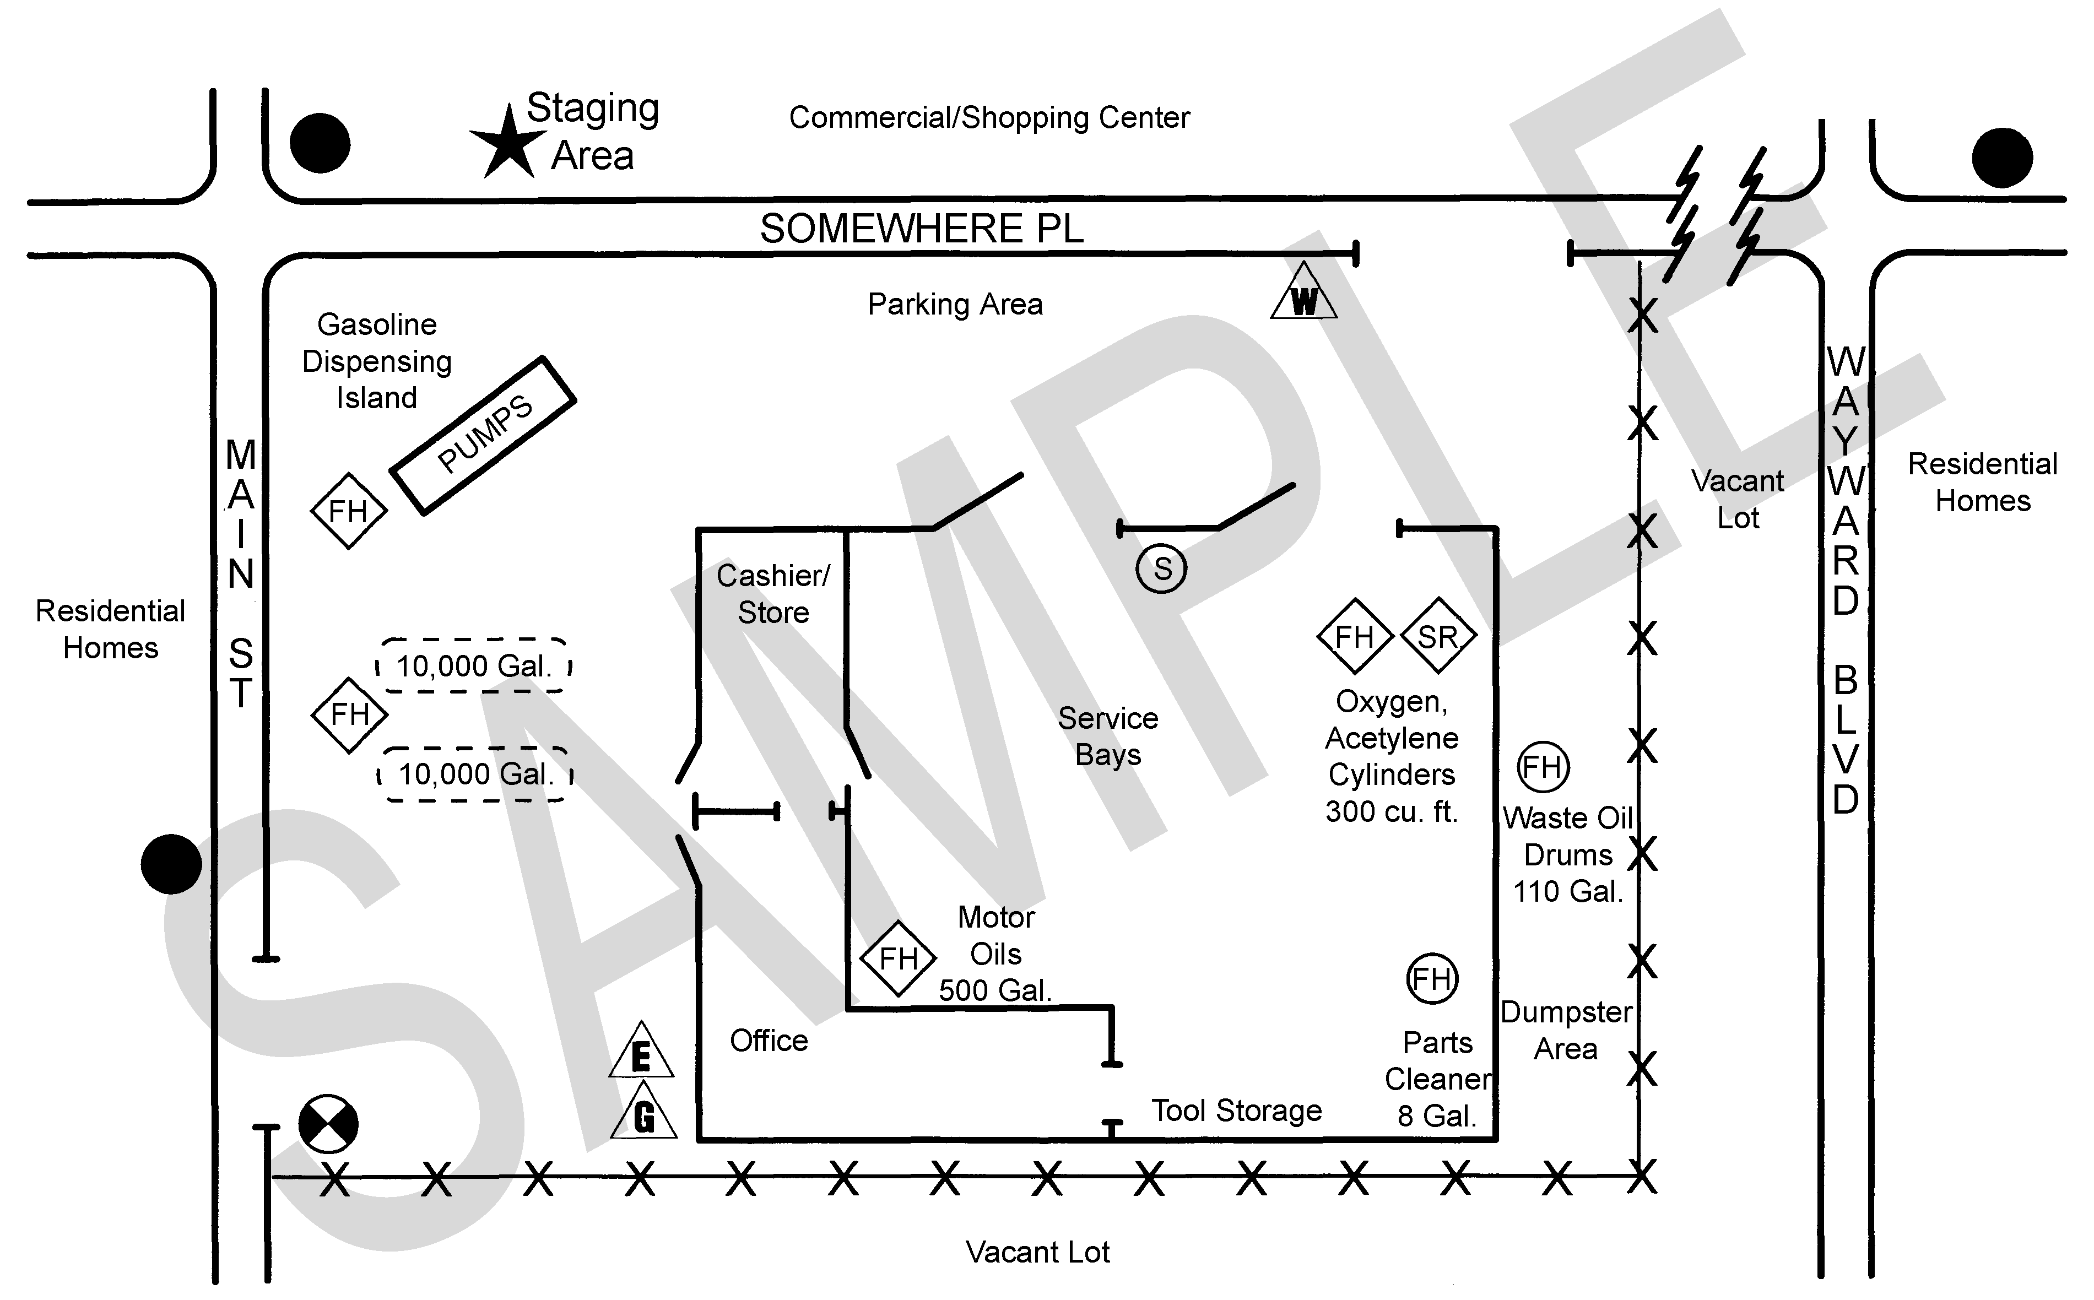

Motor Oils
500gal

Spill Kit
Gasoline
Dispensing
Island

+

SITE MAP (Page ____of____)

BUSINESS NAME DATE

BUSINESS ADDRESS

N

N

O

T

F

O

R

P

U

B

L

I

C

D

I

S

C

L

O

S

U

R

E

This Page Intentionally Left Blank

