HAZARDOUS MATERIALS BUSINESS PLAN

II. Chemical Inventory and Site Map (continued)

Federal Reporting Requirements - EPCRA Tier II
The Emergency Planning Community Right to Know Act (EPCRA) requires industry to disclose chemical storage, chemical use, and chemical releases. Local government must develop emergency response plans that incorporate information provided by industry.

EPCRA requires businesses to report to state and local agencies the quantities and type of toxic chemicals stored at their facilities and releases of chemicals into the environment. The notification for certain chemicals is then published in the Toxic Release Inventory. Businesses that do not comply with EPCRA may be subject to civil penalties and may be required to cover costs of litigation and/or environmental remedial actions. For more information about EPCRA reporting, read Subchapter III, Section 11023.
See: http://www.gpo.gov/fdsys/pkg/USCODE-2011-title42/html/USCODE-2011-title42-chap116.htm

EPCRA has four provisions that are important to businesses: hazardous chemical storage reporting requirements, emergency planning, emergency planning notification and toxic release inventory reporting. Most of these may be addressed through proper submittal of an HMBP to the CUPA in CERS.

Hazardous Chemical Storage Reporting Requirements - EPCRA facilities must submit emergency contacts and hazardous chemical inventory through CERS annually. This information includes: hazardous chemicals at or above 10,000 pounds, extremely hazardous substances above 500 pounds, or above a defined threshold planning quantity (TPQ) (whichever is less); and chemicals at or above TPQs handled during the last calendar year.
Emergency Planning - The emergency planning section of the law is designed to help communities prepare and respond to emergencies involving hazardous substances. Every community in the United States must be part of a comprehensive plan. These plans are based on information provided in reports from EPCRA facilities. In San Diego County, the Hazardous Incident Response Team (HIRT) is an integral part of emergency planning and includes members from the County of San Diego HMD and City of San Diego Fire and Rescue Department. The information provided by businesses allows HIRT and the Fire Department to respond efficiently to chemical emergencies and protect human health and the environment.
Emergency Planning Notification - EPCRA facilities must notify the Local Emergency Planning Committee (LEPC) and the State Emergency Response Commission (SERC) immediately if there is a release of a hazardous substance into the environment that is equal to or exceeds the minimum reportable quantity set in the regulations. This requirement covers 356 extremely hazardous substances and more than 700 hazardous substances subject to the emergency notification requirements under CERCLA Section 103(a) (40 CFR 302.4). Some chemicals are common to both lists. Initial notification can be made by telephone, radio, or in person. Emergency notification requirements involving transportation incidents can be met by dialing 911. In California, a release or threatened release requires immediate reporting. Releases reported to OES and the local CUPA satisfy the EPCRA release notification. For more information on spill reporting visit the Office of Emergency Services (OES) website, or see pages 18 and 25 of this packet.

Toxic Release Inventory Reporting - Toxic Release Inventory Report must be reported to the Federal Environmental Protection Agency by July 1 of each year. This requirement applies to facilities that manufacture, process, or otherwise use a listed toxic chemical above the TPQ, and have ten or more employees.
More information on EPCRA can be found at: http://www.epa.gov/epcra

HAZARDOUS MATERIALS BUSINESS PLAN

II. Chemical Inventory and Site Map (continued) How to Comply with Federal, State, and Local Reporting Requirements
In order to avoid multiple reports to the various federal, state and local agencies, the California Health and
Safety Code (HSC) requires businesses to provide an inventory of their chemicals as part of the HMBP to the CUPA through CERS.
The Business Activities page, the Business Owner/Operator Identification page, the Hazardous Materials Inventory and Site Map that show the locations of hazardous substances must be submitted initially and re- certified annually through submittals in CERS. Update and resubmit a business plan within 30 days, when there are changes to your facility as described on page 19.
To comply with EPCRA Tier II reporting requirements, a business must have a valid Unified Program Facility Permit (UPFP) and maintain current the submittal of the HMBP, including the chemical inventory and site map to the CUPA.

State and Local Exemptions to HMBP Reporting
The following materials are exempt from reporting if certain conditions are met:
- Propane for heating, cooking, or cooling in quantities up to and including 1000 gallons
- New lubricating oils: up to 55 gallons of any specific grade of oil, not to exceed 275 gallons total combined
- Carbon dioxide for beverage carbonation: cryogenic ≤ 3500 cubic feet, non-cryogenic ≤ 6000 cubic feet
- Portable breathing air and oxygen for emergency response by government agencies (including fire)
- Medical gases (oxygen, nitrogen and nitrous oxide) in a medical office: ≤ 1000 cubic feet
- Gases used in Closed Fire Suppression Systems
- Nonflammable gases used in closed refrigeration systems (except anhydrous ammonia)
- Materials classified solely as an irritant or sensitizer: solids <5000 pounds and liquids < 550 gallons
- Inert, compressed, refrigerated or cryogenic gases (nitrogen, helium, argon, xenon, krypton, neon and non- enriched air) classified hazardous solely for pressure release or simple asphyxiation: < 1000 cf
- Compressed, refrigerated or cryogenic carbon dioxide: <1000 cubic feet
- Refrigerant gases other than ammonia or flammable gas in a closed cooling system that are used for comfort or space cooling for computer rooms
- Oil filled electrical equipment that is not contiguous to an electrical facility if the aggregate capacity does not exceed 1,320 gallons
- Fluid in a hydraulic system if the aggregate capacity does not exceed 1,320 gallons
- Hazardous materials contained solely in consumer products for direct distribution and use by the general public. These materials are typically packaged and available to the public in a retail outlet in small packages (e.g., supermarket, nursery or hardware store).

Additional Local Reporting Requirement-- Carcinogens and Reproductive Toxins
Businesses that are subject to HMBP requirements that also handle carcinogens and reproductive toxins in amounts below 55 gallons for liquids, 500 pounds for solids or 200 cubic feet of gas at standard temperature and pressure, are not required to report these carcinogens and reproductive toxins as a chemical inventory item. Instead, they must submit a list of these materials to the HMD in CERS annually based on amounts handled during the previous year. See: Disclosure of Hazardous Materials Information Bulletin HM-9243.

HAZARDOUS MATERIALS BUSINESS PLAN

II. Chemical Inventory and Site Map (continued) SITE MAP INSTRUCTIONS
Use the instructions below to develop and submit your site map to the CUPA through CERS as part of the HMBP. The site map is to assist response personnel in locating hazardous materials and responding to emergencies at your facility. Please upload site maps in PDF format, and use the Standardized Site Map Symbols and the Standardized Hazard Category Symbols only.
PLEASE NOTE: not all symbols are mandatory, however use of standard symbols (pages 9 -11) on your site map assists fire and other first responder services in an emergency at your facility. Do not use a legend with standard symbols.

SITE MAP LAYOUT
Use the following information to construct your site map:
- Site Map must be on 8-1/2 x 11 inch size paper ONLY, but does not need to be drawn to scale. For larger facilities, consider using multiple pages; one for the overall layout of the facility and additional pages for individual buildings. Rural areas should include an inset vicinity map of the greater area. Site maps with multiple pages must be uploaded to CERS as a single file.
- Maps should be black & white line drawings. Do not use color coding.
- All labels, symbols, writing, printing shown on the site map must be legible and oriented in the same direction. Maps may be drawn on a computer or by hand using a ruler or template to draw the lines and symbols.
- Do not use large documents (such as blue prints) unless the scaled-down result is clearly legible. Engineering markings and other non-essential items should be removed for clarity.
- Show structures from an overhead perspective. Show only the exterior walls of small buildings and include all exits and entrances. Interior walls may be shown for complex or large facilities.
- Include roads that provide access and exit points to the facility, including driveway entrances, internal roads, parking lots, loading areas and adjacent streets.
- Indicate all hazardous materials/waste handling and storage areas using appropriate symbols.
- Indicate all emergency and main utility shutoffs using appropriate symbols. If you do not have a utility service (such as gas), it is helpful to indicate this inside a cloud (e.g. “no gas”) on the map.
- Indicate evacuation staging area using appropriate symbols.
- Indicate storm and sewer drains using appropriate symbols.
- Indicate fire hydrants and other fire department connections using appropriate symbols.
- Indicate other emergency response equipment (fire extinguisher, eye wash, spill kit) using appropriate symbols or by labeling the location of emergency equipment on the site map.
- In the upper left corner, indicate the North orientation by drawing an arrow pointing north.
- Label adjacent property usages (school, park, industrial, residential, commercial, vacant, etc.).

SITE MAP STANDARD SYMBOLS

Entrances/Exits: Use this symbol for all exterior doors of structures, including roll-up doors.
Fences: Use this symbol for fences (e.g. chain link, wood, etc.), block walls, or any other barriers that act as a fence. (Note: include both external and internal fences). | x x x x
Sewer Drain: Use this symbol to show all sewer drains, including floor drains to sewer, sewer sumps, etc. (Note: do not include toilets and sinks). | S
Storm Drain or Culvert: Use this symbol to indicate the location of all storm drain inlets, culverts, drainage ditches and other rain water diversion features on the property. If none are present in the scope of your map, indicate the distance to the nearest storm drain using an arrow to indicate the direction and this symbol. | 
Electric MAIN Shut Off: Use this symbol to indicate only the electric main shut-off or the entire facility, structure, or building. | E
Water MAIN Shut Off: Use this symbol to indicate only the water main shut-off for the entire facility, structure, or building. | W
Gas MAIN Shut Off: Use this symbol to indicate only the natural gas main shut-off for the entire facility, structure, or building. You may indicate “no gas” in a cloud if there is no gas service. | G
Emergency Response Equipment: Use this symbol to indicate the location of emergency response equipment such as spill kits, fire extinguishers, and eye wash stations. A text label may be used to differentiate emergency response equipment types. | +
Fire Hydrants: Use this symbol to identify all fire hydrants in the vicinity of your facility. If none are present in the scope of your map, indicate the distance to the nearest fire hydrant using an arrow to indicate the direction and this symbol.
Fire Sprinkler System Connection: Use this symbol to identify the building/structure fire department sprinkler system connections if present at your facility. (Note: these are normally located outside in locations accessible to the fire department. Do not include landscape sprinkler connections). | 
Fire Department Standpipe Outlet: Use this symbol to identify the fire department standpipe fire hose connections if present at your facility. (Note: these connections are typically found inside buildings and in stairwells of multi-story buildings.)
Knox Box (Fire Department Key Box): Use this symbol to indicate the location of the Knox Box (a locked box containing keys or information for the Fire Department.) if present at your facility. | K
Annunciator Panel: Use this symbol to indicate the location of the Annunciator Panel if present within the facility. An annunciator panel indicates the zone or area from which an alarm has been initiated; or the location of an alarm-initiating device and the operational condition of the alarm circuits of the system. | AP
Stairwell - Range of Floors (e.g., B thru 5): Use this symbol to indicate interior stairwells, if present. Indicate the floor the stairwells begin and end on. For roof access use the abbreviation R. For basement access use the abbreviation B and include the number of basement floors
 |  | 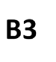 |  |  |  |  |  |  | 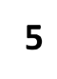
Elevator - Range of Floors (e.g., B thru R): Use this symbol to indicate the elevators in the interior of a structure or building, if present. Indicate the floor the elevator begins and ends on. For roof access use the abbreviation R and include the beginning floor level. For basement access use the abbreviation B and include the number of basement floors. | 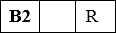

Safe Refuge Area (Evacuation/Staging Area): Use this symbol to indicate the location that has been designated as the assembly area where plant or business personnel will assemble in the event of an emergency evacuation.
Aboveground Storage Tank and Capacity: Use the correct circle or oval symbol for aboveground storage tanks onsite, if present. Include the tank capacity within the symbol using the appropriate unit of measure as reported in CERS. Also include the appropriate hazard category symbols (diamonds or circles) for the tank contents. See below. |  | 500  90
Plating or Processing Tanks: Use this symbol for all plating and process tanks if present at your facility. Also include the appropriate hazard category symbols (diamonds or circles) for the tank contents. See below. |  | 5, 000
Underground Storage Tank and Capacity: Use this symbol for underground storage tanks onsite, if present. Include the tank capacity within the symbol with the appropriate unit of measure as reported in CERS. Also include the appropriate hazard category symbols (diamonds or circles) for the tank contents. See below. |  | 500
HAZARD CATEGORY SYMBOLS: Use the symbols below to identify the location and hazards associated with hazardous materials stored in reportable quantities and all hazardous wastes handled at your facility. Use your Safety Data Sheet or other technical resources (such as 49 CFR 171.101) to determine the appropriate hazard class(es) for each. | USE DIAMONDS  FOR MATERIALS | USE CIRCLES FOR WASTES
IMMEDIATE (ACUTE) HEALTH HAZARD: An adverse effect resulting from a short-term exposure to a chemical. Includes highly toxic, toxic, irritant, sensitizers, corrosive chemicals. Examples: cyanide, hydrochloric acid, sodium hydroxide, and chlorine. | IA | IA
DELAYED (CHRONIC) HEALTH HAZARD: An adverse effect resulting from long-term exposure to a substance. The effects could be a skin rash, bronchitis, cancer or any other medical condition. Examples include carcinogens such as benzene, formaldehyde, or methylene chloride. | DC | DC
FIRE HAZARD: Includes flammable liquids and solids, combustible substances, pyrophorics and oxidizers. Examples include solvents like acetone and alcohol, solvent based paints, gasoline, naphtha solvent, acetylene gas cylinders, propane gas. | FH | FH
SUDDEN RELEASE OF PRESSURE: This category includes explosives, blasting agents and compressed gases. Examples: nitrogen, oxygen, acetylene, helium, carbon dioxide, etc. | SR | SR
REACTIVE: This category includes unstable air reactive, water reactive or shock materials. Examples: organic peroxides, fine metal dusts like magnesium, aluminum, phosphorous, cyanides, sulfides and picric acid | R | R
MEDICAL (BIOHAZARDOUS) WASTE: Medical or biohazardous wastes generated in medical, dental and lab settings. Typically needles and syringes in sharps containers, infectious materials in biohazard bags, clinical and microbiological lab specimens and some pharmaceutical waste. | Use the appropriate symbol from this column | IW
RADIOACTIVES: Includes mixed waste and radioactive sources used in labs and industrial settings. Examples include: Scintillation materials, nuclear medicine waste and R & D materials and waste. | RA | RA
EXTREMELY HAZARDOUS: Includes materials listed in Appendix A of Part 355 of Subchapter J of Chapter 1 of Title 40 of the Code of Federal Regulations. Examples include fluorine gases, silane, and fumigation gases. | XH | XH

HMBP STANDARDIZED SITE MAP SYMBOLS

SITE MAP SYMBOLS HAZARDOUS MATERIALS STORAGE/USE AREA SYMBOLS

ENTRANCE/EXIT FENCE SAFE REFUGE AREA

x x x x

IMMEDIATE (ACUTE) HEALTH HAZARD
An adverse effect resulting from a short-term exposure to a chemical. Includes highly toxic, toxic, irritant, sensitizers, corrosive chemicals. Examples: cyanide, hydrochloric acid, sodium hydroxide, chlorine gas
MATERIAL WASTE

EMERGENCY RESPONSE EQUIPMENT
+

SEWER DRAIN
S

FIRE HYDRANT

STORM DRAIN OR CULVERT


DELAYED (CHRONIC) HEALTH

IA

IA

DC

DC
An adverse health effect resulting from long-term exposure to a substance. The effects could be a skin rash, bronchitis, cancer or any other medical condition. Examples include carcinogens such as benzene, formaldehyde, and methylene chloride.

FIRE SPRINKLER F.D. STANDPIPE
CONNECTION OUTLET KNOX BOX

K
STORAGE TANKS AND CAPACITY UNDERGROUND ABOVE GROUND PLATING TANKS

OR
5, 000
50
500
500

MAIN UTILITY SHUT OFFS

IW
FIRE HAZARD
Includes flammable liquids and solids, combustible liquids, pyrophorics and oxidizers. Examples include solvents like acetone and alcohol, solvent based paints, gasoline, naphtha solvent, acetylene gas cylinders, propane gas.

FH

FH

SUDDEN RELEASE OF PRESSURE
SR
R

SR
This category includes explosives, blasting agents and compressed gases. Examples: nitrogen, oxygen, acetylene, helium, carbon dioxide, etc.

REACTIVE

R
This category includes unstable air reactive, water reactive or shock materials. Examples: organic peroxides, fine metal dusts like magnesium, aluminum, phosphorous, cyanides, sulfides and picric acid.

ELECTRICAL GAS WATER MEDICAL (BIOHAZARDOUS) WASTE
Medical or biohazardous wastes generated in medical, dental and lab settings. Typically needles and syringes in sharps containers, infectious materials in biohazard bags, clinical and microbiological lab specimens and some pharmaceutical waste.

E

G

W

RADIOACTIVES
Use the appropriate symbol from this column

ANNUNCIATOR PANEL
AP
STAIRWELL
(i.e. 1 thru 3)

ELEVATOR
Range of Floors
Includes mixed waste and radioactive sources used in labs and industrial settings. Examples include: Scintillation materials, nuclear medicine waste and R & D materials and waste.
EXTREMELY HAZARDOUS

XH

RA

XH

RA
Includes materials listed in Appendix A of Part 355 of Subchapter J of Chapter 1 of Title 40 of the Code of Federal Regulations.
Examples include: Fluorine gases, Silane, Fumigation gases

SAMPLE SITE MAP (Page 1 of 1)

BUSINESS NAME Joe’s Automotive Repair DATE 02/09/2016
BUSINESS ADDRESS 1234 Somewhere Pl., Anywhere, CA 92123

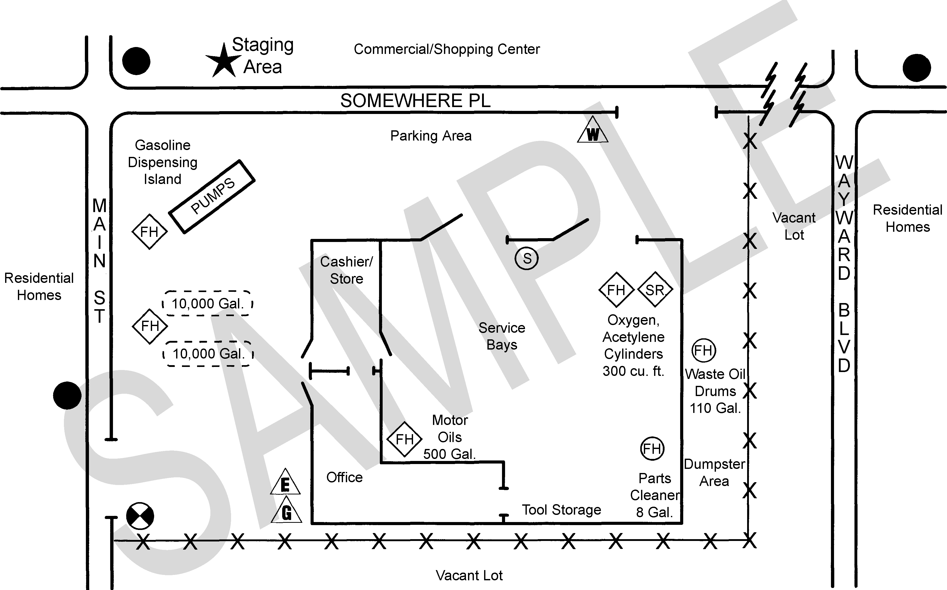N

Gasoline Dispensing Island

Motor Oils

500gal
Spill Kit
+

SITE MAP (Page of )
BUSINESS NAME DATE BUSINESS ADDRESS
N
N O T

F O R

P U B L I C

D I S C L O S U R E

This Page Intentionally Left Blank

