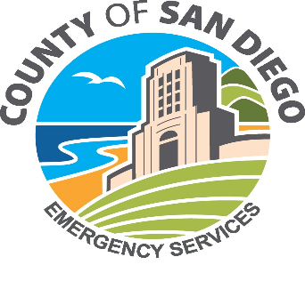 | County of San Diego Office of Emergency Services  5580 Overland Ave., Suite 100  San Diego, CA 92123 -1251  Phone: (858) 565-3490 | 

UDC GRANTS SUBCOMMITTEE MEETING OF
MARCH 25, 2026
AGENDA

- Welcome & Introductions
- FY2026-27 UDC Budget Proposal & Member Shares (informational item)
- Closing Remarks

