County Hydrology Manual Lag Time Equation 4-17 (p. 4-33) – applicable for drainage areas greater than 1 square mile:
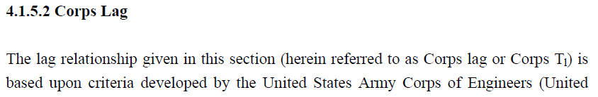
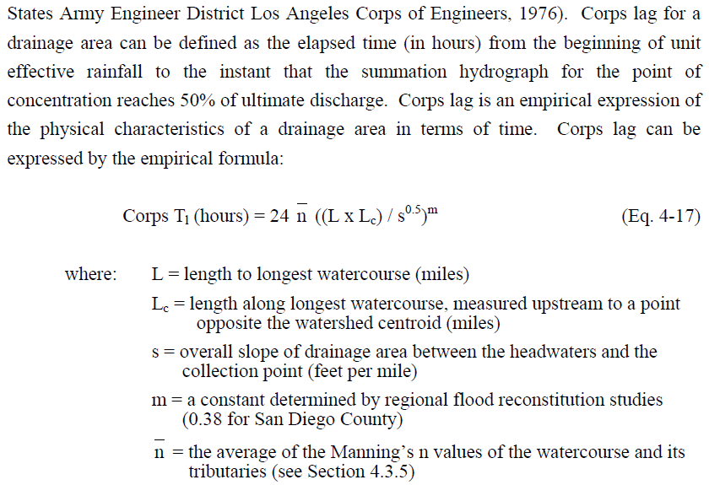

County Hydrology Manual Lag Time Equation 4-22 (p. 4-36) – applicable for converting T_{c} when transition from 1 square mile watershed to greater than 1 square mile watershed occurs within the project boundary:
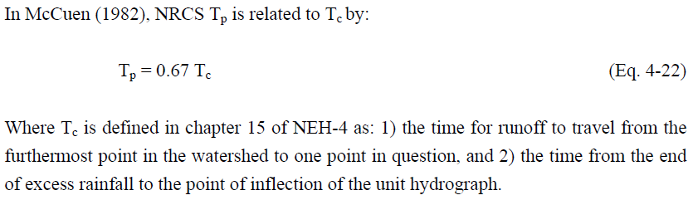

National Engineering Handbook T_{c} Equation 15-4b used by applicant (p. 15-5):
