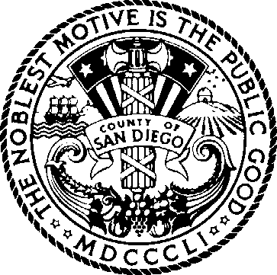
COUNTY OF SAN DIEGO JUVENILE JUSTICE COORDINATING COUNCIL

May 29, 2024
1:00 – 2:30

Youth Transition Center (YTC) Training Room
2801 Meadowlark Drive; San Diego, CA 92123

BOARD OF SUPERVISORS
NORA VARGAS
First District
JOEL ANDERSON
Second District
TERRA LAWSON-REMER
Third District
MONICA MONTGOMERY STEPPE
Fourth District
JIM DESMOND
Fifth District

Item | Subject
1 | Opportunity for Public Comment  Limit two minutes per speaker
2 | Welcome and Introductions
3 | Review Minutes (Action)
4 | JJCPA Funding 2024/25
5 | SB 823 Annual Plan
6 | Freedom2Succeed
7 | Updates  Probation Public Defender  District Attorney SDCOE  BHS  Other
8 | Legislative Update
9 | Kearny Mesa Master Plan - Phase 2
10 | Future Agenda Items

If you are planning to attend and need special accommodations, please call Brook Smith at (858) 581-5882 at least three days in advance of the meeting.

Pursuant to Government Code section 54957.5, materials distributed to the Juvenile Justice Coordinating Council in connection with this agenda less than 72 hours before the meeting will be made available to the public at https://www.thechildrensinitiative.org/jjccmeetings or https://www.sandiegocounty.gov/content/sdc/public_safety.html.

